**Flink Setup**

* Download Flink 1.9.2 version

Reference: <https://archive.apache.org/dist/flink/flink-1.9.2/>

Use file: flink-1.9.2-bin-scala_2.12.tgz

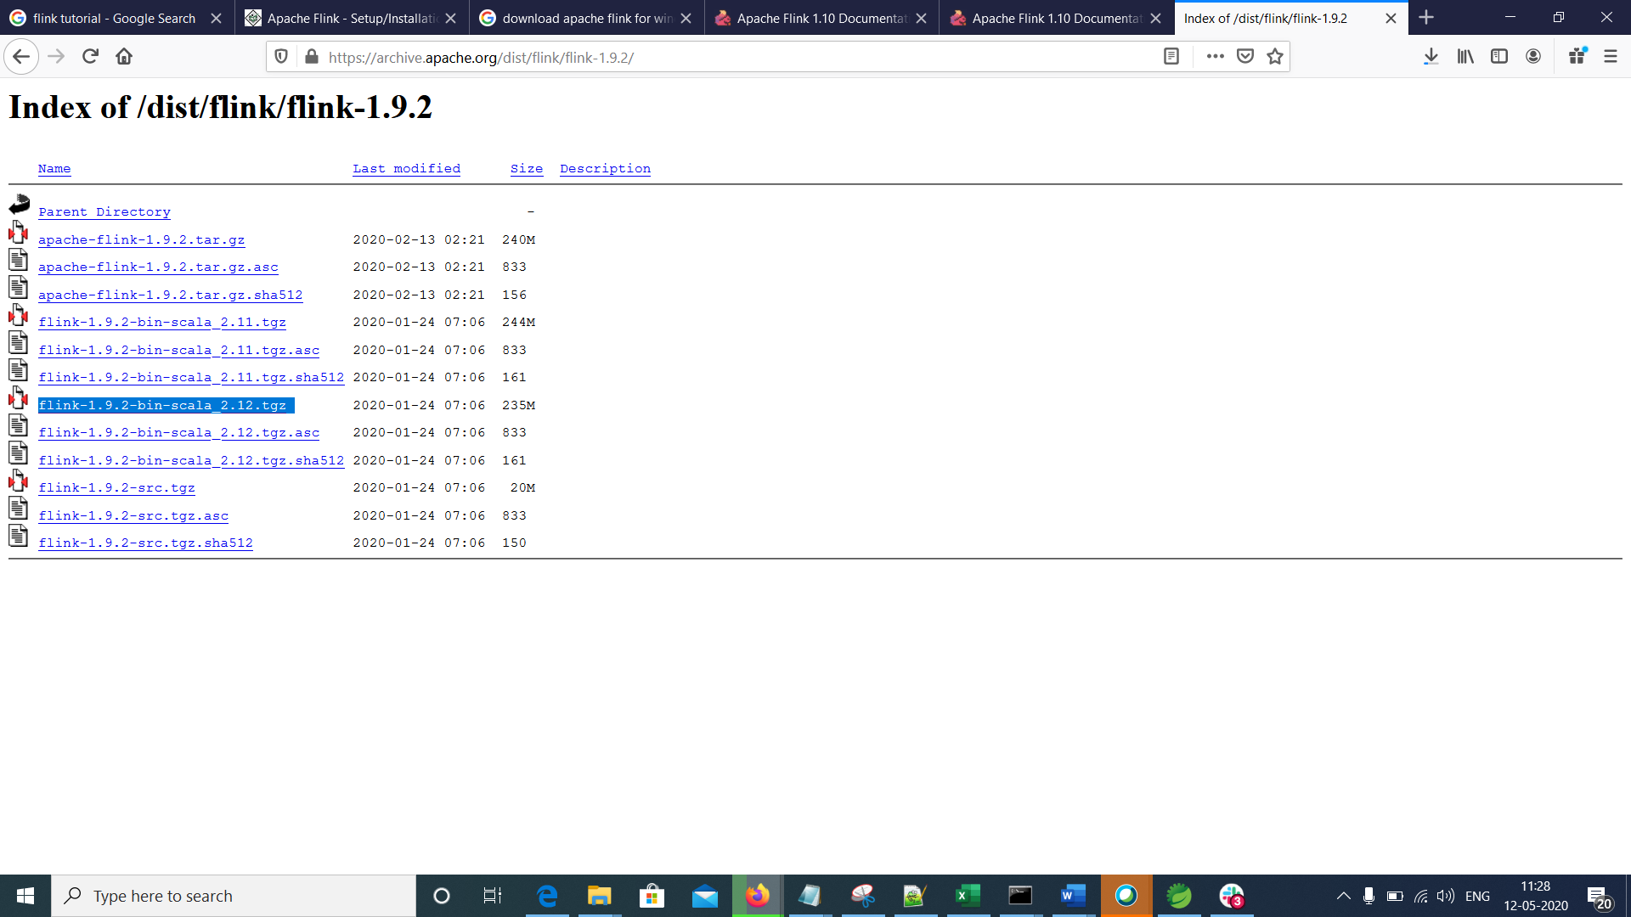

* Extract the tar file using Cygwin

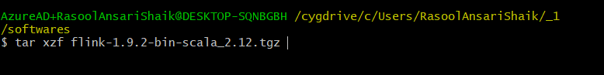

* You can see the extracted flink1.9.2

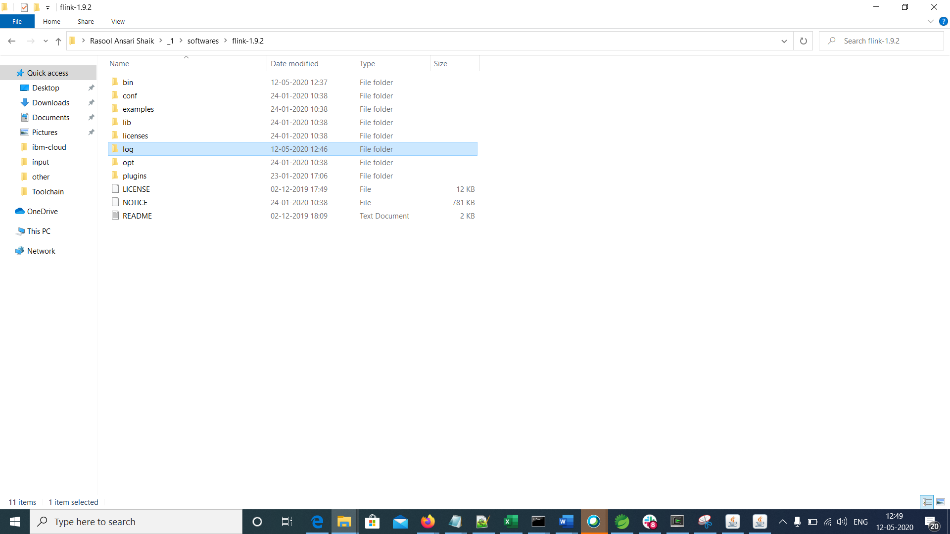

* Start flink cluster (use command line start-cluster.bat)

Note: Do not use start-cluster.sh as it is not working properly with Cygwin. Don’t know the proper reason for it

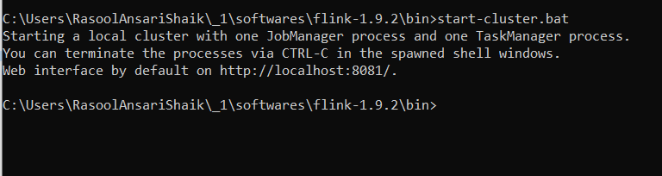

This will open 2 separate command lines

* Run localhost:8081 to open flink dashboard

